Pre Ap Computer Science I Jeroo Lab 5A – Flower Maze Lab Value - 100

Lab Goal: To analyze a problem and involve basic decision making in creating a solution for the problem. You must determine how to use compound conditionals in order to move through the maze. You must create methods involving complex conditionals so that your Jeroo can continue to move. Pay close attention – it will only require a few basic decisions if you take a careful look at the decisions that need to be made.
Lab Description: This lab requires you to use the commands AND ( && ) and OR( || ) in order to create the methods needed. Your Jeroo must make its way through the entire maze and stop facing the water. You can solve this with just a few methods Think in simplest terms. It is not as difficult as it first appears. Methods will definitely be used more than once.

Starting Screen:
Files Needed:
Jeroo_Lab5A.jsc
FlowerMazeIsland.jev

algorithm help

Preconditions
- What makes me stop?
- Which way do I turn?
- When do I stop?
- Why do I move?

Postcondition
- Successful hop through the maze.
- Jeroo is not in the water.
- Jeroo is facing North.
- Jeroo is facing the water.
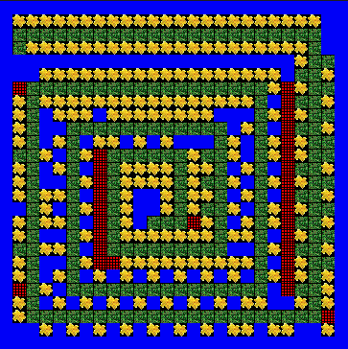

Ending Screen:
